**Applying One Hot Encoding**

If you see our y_train variable contains Labels representing the images containing in x_train. AS these are numbers usually they can be considered as numerical or continuous data, but with respect to this project these Numbers are representing a set of class so these are to be represented as categorical data, and we need to binaries these categorical data  that's why we are  applying One Hot encoding for y_train set

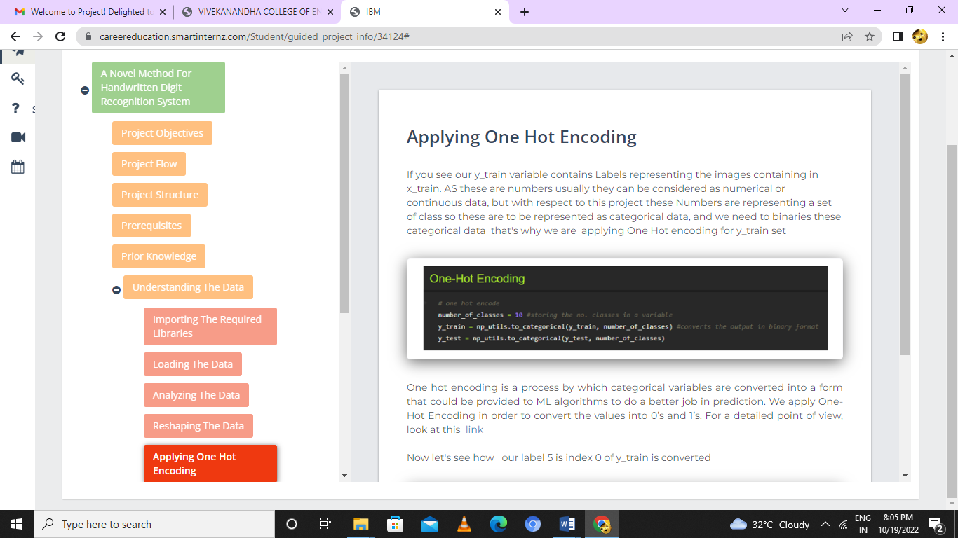

One hot encoding is a process by which categorical variables are converted into a form that could be provided to ML algorithms to do a better job in prediction. We apply One-Hot Encoding in order to convert the values into 0’s and 1’s. For a detailed point of view, look at this  [link](https://deeplizard.com/learn/video/v_4KWmkwmsU)

Now let's see how   our label 5 is index 0 of y_train is converted